Cyber Legislation and Compliance
Group Members: Arda Karabulut, Shehab Ahmed, Munzer Elsarafandi
Thread number: 11
Thread Name: Increased digital currency-enabled cybercrime
Thread Description: By 2030, digital currency-enabled cybercrime will increase rapidly. Cryptocurrencies, and the broad market adoption of them, already have enabled organized crime to expand their reach. Because digital currencies will be very commonly used as an investment asset and means of payment in European markets, organized crime may be able to expand their targets. This means that cybercrime groups offering professional services (cyber-attacks) will be better funded because of an increase in the efficiency and effectiveness of their efforts.
Section B:
Scenario: A cybercriminal group targets a major hospital network in Kilkenny, encrypting patient records and locking critical and essential systems (e.g. scheduling software, care unit monitoring software) throughout the hospital network. They demand payment in Bitcoin making the attackers difficult to trace. The hospital is forced to divert emergency patients, cancel surgeries and revert to paper records. Even after partial recovery, public trust in the hospital’s infrastructure and security remains deeply shaken.

Stakeholders impacted:
- Patients in critical care: With monitoring systems affected, their treatment may be compromised. Medical staff must rely on manual monitoring to track vital signs and coordinate care, which will increase the risk of errors and placing extra work pressure and stress on both patients and staff.
- Patients with ongoing treatment: Patients with ongoing treatments, such as chemotherapy, dialysis or scheduled surgeries, face interruptions and confusion because hospital’s systems will be down. Appointments may be postponed, and treatment plans may change when the case is diverted to another doctor at another hospital.
- ER Patients: Emergency Room patients will experience immediate consequences of this attack due to the automation system is depending on monitoring software. Potentially, for every ER patient a medical personnel will be assigned, which will lead to shortage of work force.
- Hospital staff: The hospital staff (e.g. nurses, laboratory technicians, healthcare professionals) will be affected due to the shortage of patients in the hospital. Also, the hospital may decide to downsize and some of the staff may lose their jobs. In addition, nurses will have a harder time to monitor the patients due to lack of monitoring software.
- Hospital IT department: IT team will need to work extra shifts during this period to recover data carefully from a backup, if it exists. Some people in the IT department may lose their jobs if they will be shown as the reason of this attack.
- Surgeons & Doctors: Due to diversion of patients the surgeons and doctors schedule will be changed and if the patient records are lost, doctors need to diagnose the patients again.
- Hospital administration: Hospital administration will be under stress during this period and may need to take serious actions and that can mentally and physically overwhelm.
- Pharmacists: Because patients will be diverted to nearby hospitals, their work force will be affected.
- Hospital suppliers: Because patients will be diverted to nearby hospitals, operations regarding patients and the maintenance will slow down and numbers will decrease leading to less need of items leading to less income to suppliers.
- Hospital catering firm: The firm will be affected because of that accident the population of the hospital will decrease significantly, and the firm would not get that much order as before the crisis.
- Family members of the patients: Because of this attack patients who need immediate and regular care may pass away or during this period patients may be sent to their relatives’ home requiring patient’s family members to take time off from work to care for them. Additionally, families may need to travel farther to access services.
- Nearby hospitals: Because of the attack nearby hospital’s patient capacities will face extra pressure and lead to less careful examination to their original patients.
- Insurance companies: In the recovery phase insurance companies may need to pay large sums of money to support hospitals in restoring their infrastructure and resuming their normal operations.
- Cybersecurity firms:
- Law enforcement: During this period, law enforcement will be immediately notified and involved in investigation with cybersecurity firms. Because health information is at risk the investigation will use significant amounts of work force.
- General public: The public will experience delays in medical care and their trust to the hospital will be shaken due to “uncertainty” about how patients’ information is protected.
- Transport services: Specifically, ambulance services will be heavily affected while diverting patients leading to slower response times for emergency cases.
- Medical students and interns: There will be significant disruption to their training because the medical staff and doctors will be overwhelmed with the paper records. However, working under extreme conditions can teach stress and crisis management.
- Technical support: During the recovery period, technical support staff will play a critical role in restoring hospital’s systems while assisting other organizations. They must manage multiple tasks during that period (e.g. answering calls from the public and reporters, helping recovery team to configure systems properly)
- Funeral Homes and Crematories: Funeral homes and crematories may face delays in receiving notifications about patients' deaths and can experience extra work pressure.

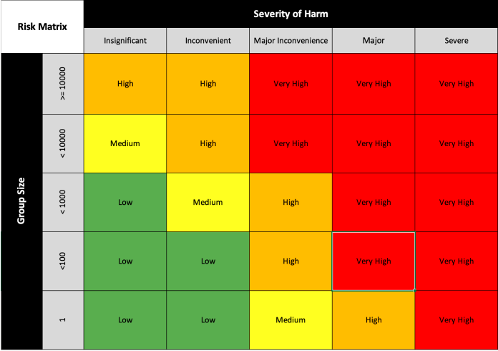
Under this thread name, this scenario’s vulnerable stakeholders (directly and indirectly affected) fall under the group size of >=10000 and the severity of harm of severe in the Stakeholder Impact Matrix. This is because not only are patients that are in life-or-death situations being forced to wait with no guarantee of their future, but all hospital staff and equipment are being placed on hold (surgeries postponed, ICU units locked, etc.).
Furthermore, a heavy mental toll is being placed on secondary stakeholders, such as family members of patients and staff. Worries between families not getting needed medication or treatment, and doctors, nurses and surgeons being on constant overtime to recover isn’t an easy task to go through.
Finally, we get to the first responders and recovery units in this stakeholder vulnerability assessment and analysis, such as insurance companies and law firms. The responsibility of helping the hospital recover from this attack is burdened on these recovery units that have a duty outside the hospital.
Overall, the risk this hospital had that the attackers exploited was critical to primary stakeholders that, if remained untreated, would count deaths under the hospital’s name, and secondary stakeholders, which had to bear the mental stress of helping family members in direct aid of the hospital or direct aid for the hospital. This scenario would certainly be placed in the “Very High” category, with necessary improvements for security to progress through.

Access to Individual Journals:
Shehab Ahmed: https://setuo365-my.sharepoint.com/:w:/r/personal/christopher_staff_setu_ie/_layouts/15/Doc.aspx?sourcedoc=%7BC38A4280-E736-4CD4-8B76-118E77389AAA%7D&file=Ahmed-IND-CLC.docx&action=default&mobileredirect=true
Arda Karabulut: https://setuo365-my.sharepoint.com/:w:/r/personal/christopher_staff_setu_ie/_layouts/15/Doc.aspx?sourcedoc=%7BE7EC1BBD-FC97-49AF-859E-4DFF84B56491%7D&file=Karabulut-IND-CLC.docx&action=default&mobileredirect=true
Munzer Elsarafandi: https://setuo365-my.sharepoint.com/:w:/r/personal/christopher_staff_setu_ie/_layouts/15/Doc.aspx?sourcedoc=%7B724D8581-3D4D-46BF-A5F9-1E0247A95776%7D&file=Elsarafandi-IND-CLC.docx&action=default&mobileredirect=true

Part C: Decide whether you are an important SMB or an essential large corporation and briefly describe several critical and sensitive information assets held by the organisation. There should be at least as many assets are there are members in your team. You should show how the assets are relevant to the unwanted incident in your scenario.
The hospital is an essential large corporation because it employs thousands of staff (medical, administrative, IT staff etc.), provides health services to a region with a population of 30.000 people (number is estimated population of Kilkenny from 2022).

Critical and sensitive information assets:
- Electronic Health Records: Contains patients’ personal information, medical history, treatment plans, contact information and next of kin’s information.
-Medication Dispensing Systems: A system that stores, manages, and dispense prescribed medications to patients. These systems are integrated with EHR to ensure accurate dosages are given and prevent errors. Any disruption to these systems could delay treatments or cause serious health risks to patients.
-Digital Imaging Machines:
-Scheduling and Patient Monitoring System:
-Network Access Control Systems:
-Financial and Billing Records:
-Staff Credentials:
-Integrated Backup Infrastructure:

